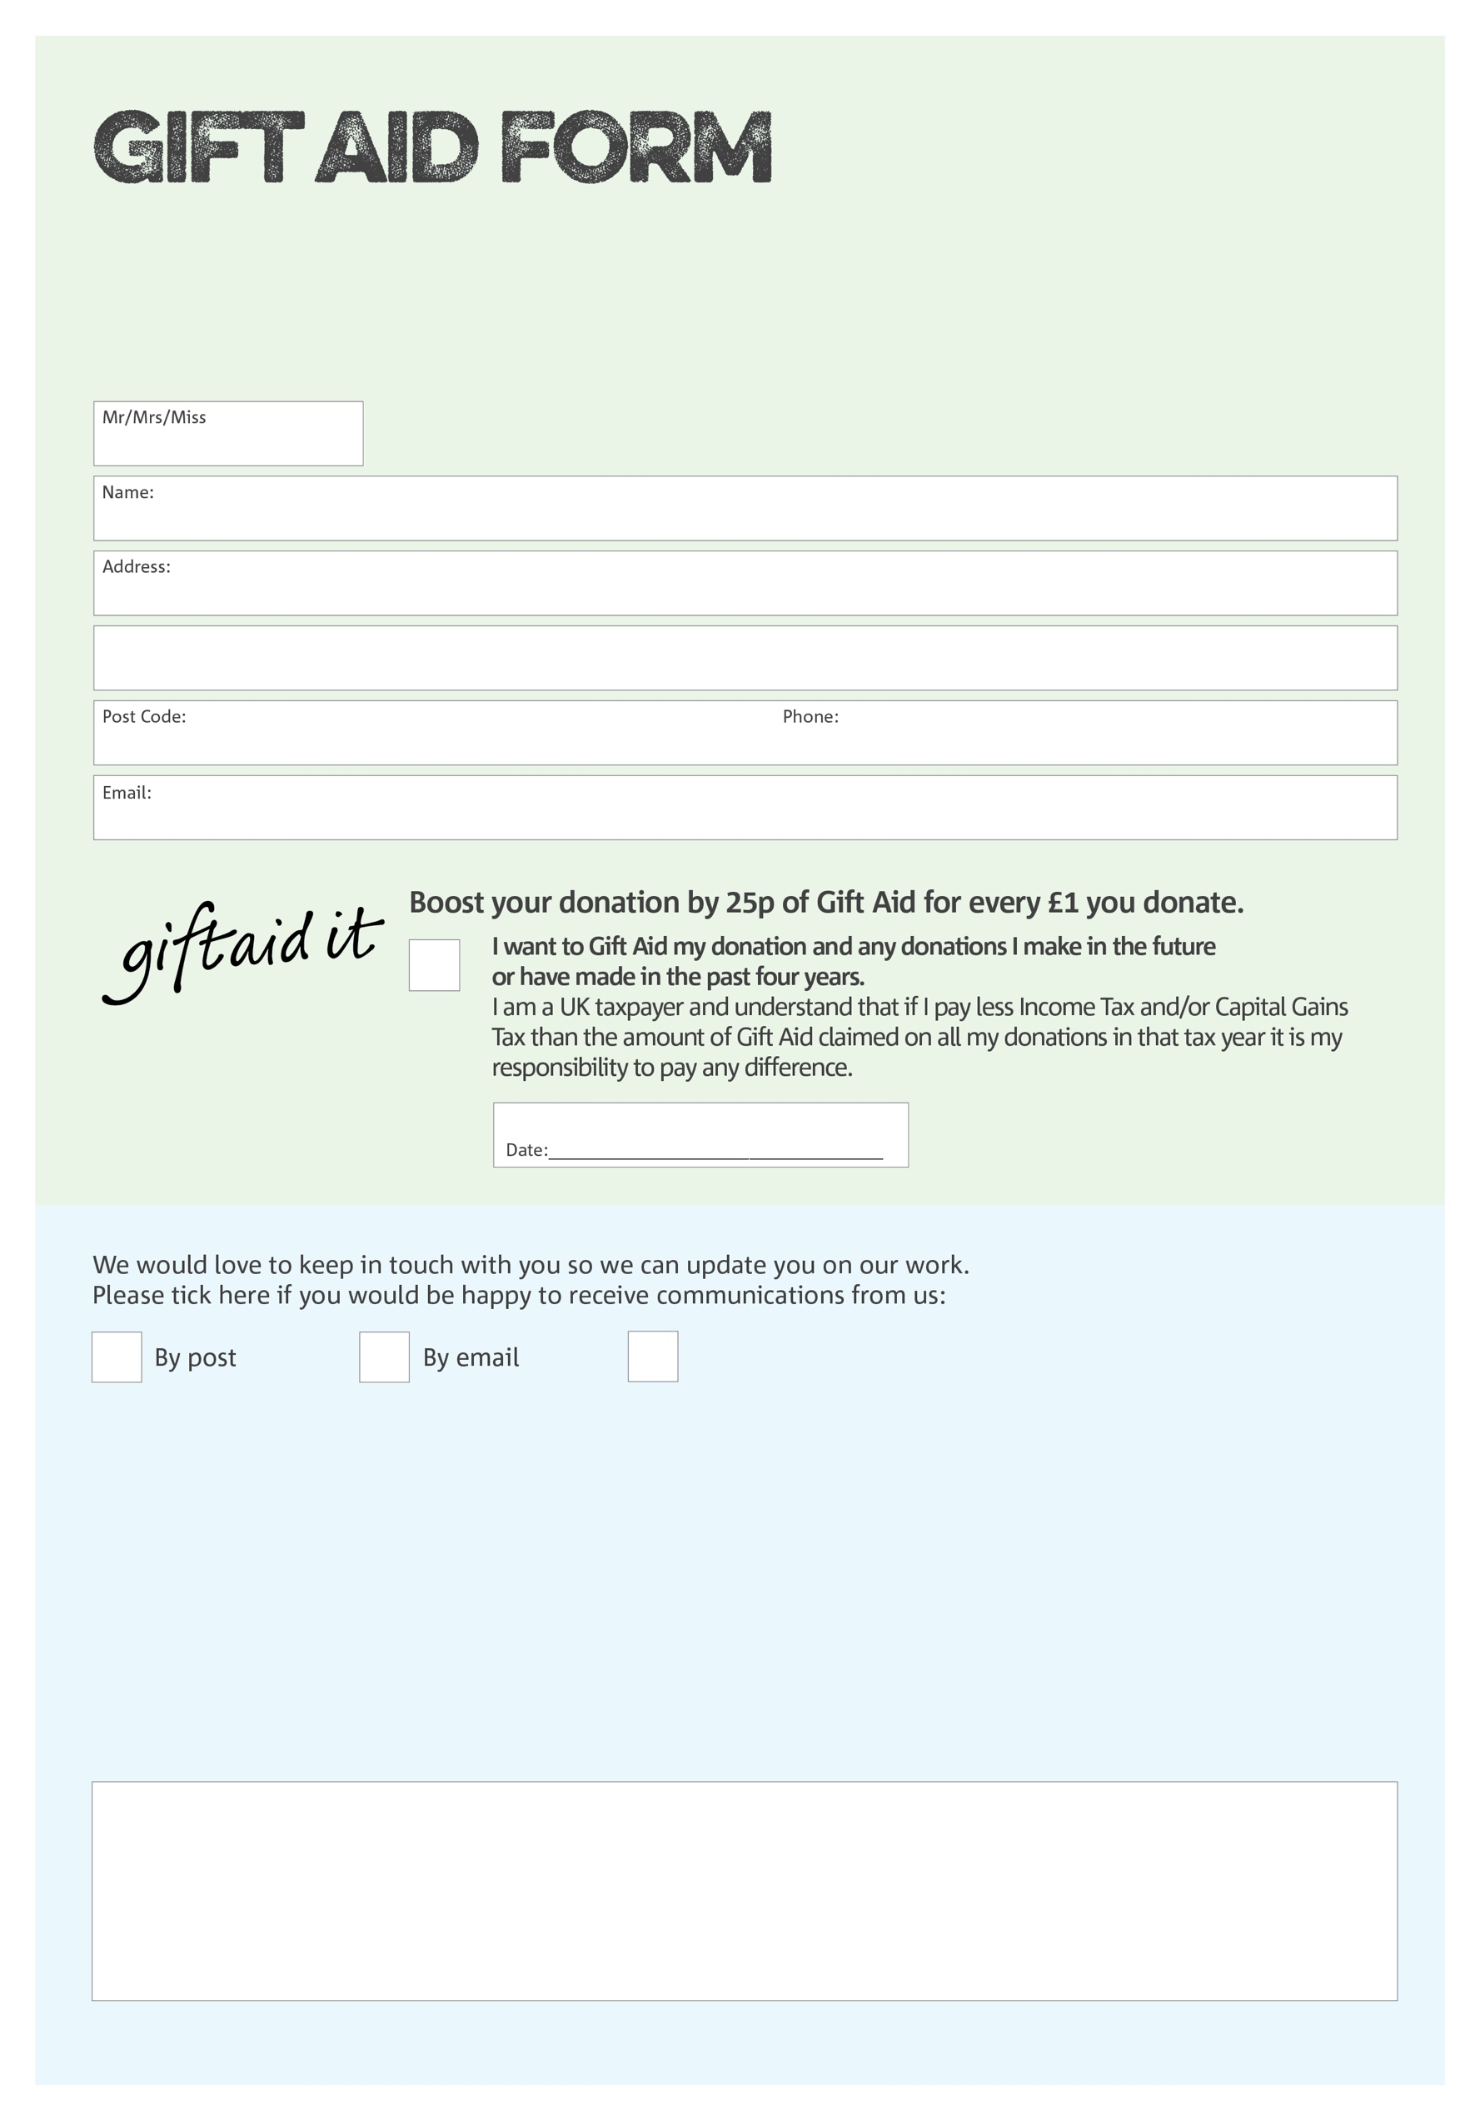

By filling in this form Bradford Central Foodbank will receive an extra 25p for every £1 you give at no extra cost to you. Thank you!

**Data protection**

*'Bradford Central Foodbank is committed to protecting your privacy and will process your personal data in accordance with current Data Protection legislation. Bradford Central Foodbank collects information to keep in touch with you and supply you with information relating to our work. To unsubscribe from our newsletter, send a message to the email address above with the word unsubscribe in the subject line. A full data privacy statement for financial donors is available from the foodbank on request.’*

You can change your preferences any time by contacting us on 01274 734314 or emailing us at

info@bradfordcentral.foodbank.org.uk

I do not wish to receive future communications from Bradford Central Foodbank

We would love to know why you have chosen to donate to Bradford Central Foodbank. If you would like to share your motivation let us know below:

Charity Number 1126516. Registered in England and Wales