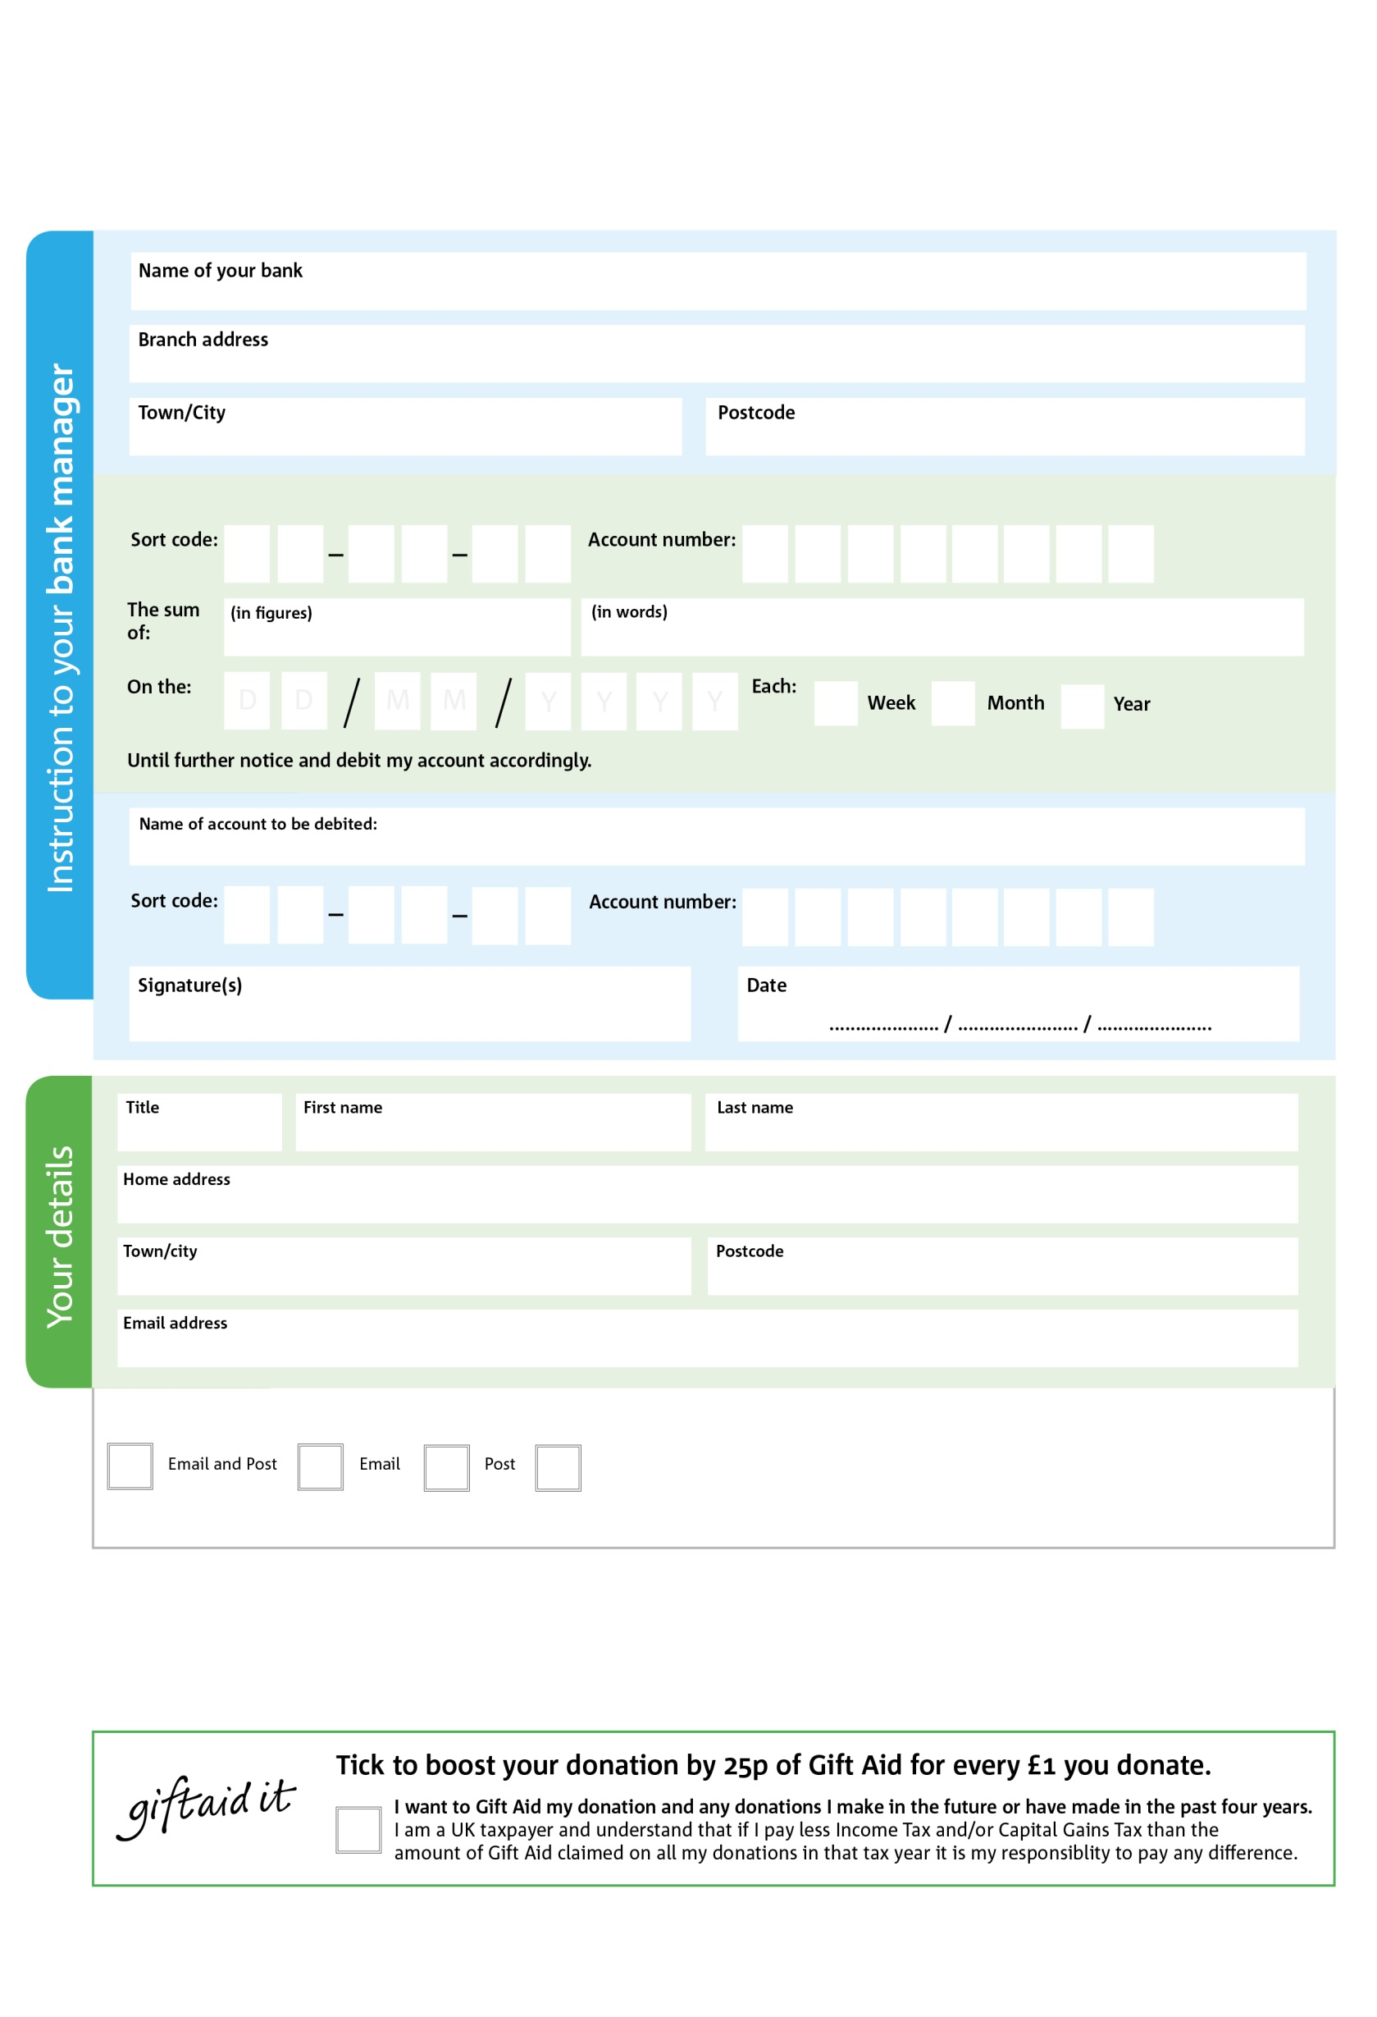

We would love to keep you up to date with information about Bradford central Foodbank. Please tick your preference:

**Standing Order Mandate**

**BradfordCentral.foodbank.org.uk**

Please pay Bradford Central Foodbank,

Reg. Charity No: 1126516 | Reg. in England & Wales

POSTAL ADDRESS: Bradford Central Foodbank, 86 Captain Street, Bradford BD1 4EL

X

V

X

V

X

V

X

V

X

V

X

V

X

V

X

V

**Please pass this form onto the foodbank, using the foodbank’s address at the bottom, who will save a copy for their records.   
They will then send it onto your named bank or building society.**

X

X

X

X

X

X

You can change your preferences any time by contacting us on 01274 734314 or emailing us at info@bradfordcentral.foodbank.org.uk

I do not wish to receive future communications from Bradford Central Foodbank

**Data protection**

*'Bradford Central Foodbank is committed to protecting your privacy and will process your personal data in accordance with current Data Protection legislation. Bradford Central Foodbank collects information to keep in touch with you and supply you with information relating to our work. To unsubscribe from our newsletter, send a message to the email address above with the word unsubscribe in the subject line. A full data privacy statement for financial donors is available from the foodbank on request.’*

You can change your preferences any time by contacting us on XXXXXXXXXXX or emailing us at XXXX@XXXXXXXXXX.foodbank.org.uk

I do not wish to receive future communications from XXXXXX Foodbank